COLINTRAIVE & GLENDARUEL DEVELOPMENT TRUST
COMMUNITY SCOPING OVERVIEW

- Project Area

Area 1 Colintraive and Glendaruel

Located in South West Cowal – a remote, rural area of Argyll. The two village centres of Colintraive and Glendaruel are 10 miles apart, with the communities covering an area stretching for around 30 miles end to end. The total population of circa 250, contained in 121 households, is reasonably equally split between Colintraive and Glendaruel. There are also 40 small businesses (see detail below). Diminishing resident populations, particularly young families, and non-viability of businesses has resulted in the deterioration of local services. The local economy depends principally on tourism with the area attracting visitors during the summer months. Agriculture and Forestry also contribute significantly to employment opportunities and the ferry operator Caledonian MacBrayne offers local employment. Currently available statistical information (2001 census updated in part by CGDT indicates that the population of Colintraive and Glendaruel has declined by some 6.3% during the last 10 years with the primary school experiencing a 17.4% decline during a similar period. The lack of reliable high speed digital connectivity is holding back businesses and the opportunity for more home working in the area.

Area 2 North Bute

Located on the Eastern side of the north tip of Bute is more than 3km from the Rothesay exchange and includes two farms, Bute Community Land Co. Bute Forest Development at Rhubodach, a boatyard and 3 residential properties. An area on the Western side of North Bute down to Ettrick Bay will also be included.

- BT Exchange Service

Exchange Name: Colintraive
Exchange Code: WSCOV
ADSL only available

Exchange Name: Glendaruel
Exchange Code: WSGLL
ADSL only available

Exchange Name: Rothesay
Exchange Code: WSROT
ADSL only available

- Existing Broadband Service

BT is the sole provider of fixed broadband services.

- Mobile Performance Data

Anecdotally the only mobile service available in Colintraive and Glendaruel is “Vodaphone” and this is patchy and is often disrupted. Ofcom have no mast listings in Colintraive and Glendaruel

- Mobile Mast Sites

Rothesay:
Name of Operator : Orange
Operator Site Reference: STR0170
Station Type: Macrocell
Height of Antenna: 15 metres
Frequency Range: 1800 MHz
Transmitter Power: 25.5 dBW
Maximum Licensed Power 32 dBW
Type of Transmission: GSM

Rothesay:
Name of Operator : O2
Operator Site Reference: STR3225
Station Type: Macrocell
Height of Antenna: 21.5 metres
Frequency Range: 900 MHz
Transmitter Power: 24 dBW
Maximum Licensed Power 32 dBW
Type of Transmission: GSM

- Local Demand

The Trust appointed an Animateur to produce robust baseline information for the Area of Colintraive and Glendaruel. The survey was carried out face to face with householders and business owners and a questionnaire for each one was completed. This survey clearly supports the need for improved Broadband Service and all individual questionnaires are available for inspection.
Please see detailed information below:

- Community Broadband Survey

Introduction

Total number of forms delivered: 161 and of these, 99 (61.4%) were completed and returned. Of the remainder, the following should be noted;
Unable to deliver 3
Holiday Homes 27
Houses for Sale/Empty 8
Refused to participate 7
No Computer 15
Not Returned 7
Questions Posed

Question 1 Name of village where you live?
Glendaruel 43
Colintraive 55

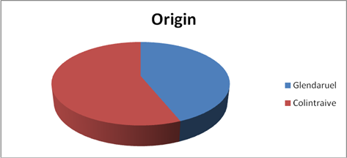

Question 2 Are you able to use the internet at this address?
All respondents 161 (100%)

Question 3 Which internet service provider do you use?
BT 75
AOL 7
Vodaphone “Dongel” 1
Smart Phone 1
Satellite 5
Sky 3
Plusnet 4
Talk Talk 2
Supanet 1

Question 4 How much do you currently pay for your Broadband each month?
Don’t Know/Not Completed 22
Up to £20 per month 41
£20/£30 per month 21
£30/£40 per month 5
Over £40 (inc. package) 8
Pay as you go 1

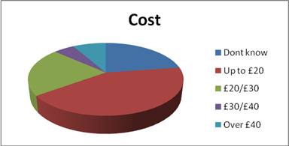

Question 5 How would you describe your current broadband connection?
Poor 81
Satisfactory 15
Excellent 3

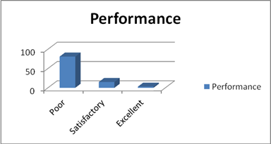

Question 6(a) Download Speed?
Below 1 meg 68
1-2 meg 5
2-3 meg 10
NB: for the users above, when there is some “outage”, or high use elsewhere, there is no broadband at all.
3-4 meg 1
4-5 meg 3
5-6 meg 2
6-7 meg 8

Question 6(b) Upload Speed?

All users (98) below 1 meg

Question 7 Would you be interested in accessing a faster broadband network?

All users (98) Yes

7.1 How much would you be prepared to pay, per month, for a faster broadband connection?

No response 16
£10-£19 31
£20-£29 35
£30-£39 8
£40-£49 6
£50 plus 2

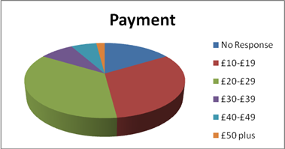

7.2 Would you use this broadband for home and/or business use
Home 100% 50
Business 100% 2
Home/Business mix:

% | Numbers
90/10 | 4
85/15 | 1
80/20 | 5
75/25 | 4
70/30 | 4
60/40 | 1
50/50 | 14
30/70 | 1
25/75 | 2
20/80 | 3
10/90 | 3

Question 8 If you have any other comments related to your Internet Service please tell us below
“ BT have stated that dial-up speeds are as fast as we can get”
“I don’t see why we should have to pay more for a faster broadband”

“Very intermittent during winter due to frequent breakdowns and slow repair response”

“Frequent interruptions”

“We are 13.8 kilometres from exchange. We don’t even have reliable telephones”

“I think it’s unfair to pay so much for such a weak service”

“The BT service is awful re speed. They ignore rural clients and are not prepared to acknowledge the v. slow speeds”

“Poor speeds make working from home very difficult”

“The limited service available at present is totally unacceptable. Would it be worthwhile polling the local internet users to contribute a one off payment of say £50 each to persuade BT to improve the service, or enable negotiation to find out what the cost of improvement would be”

“Like the majority, if not the whole of this community, I am fed up paying the same as other BT customers for a much slower service. Improvement would be an excellent boost to the community”

“Really annoyed at having to pay full price for BT broadband when the service is so terrible”

“Would like a faster upload speed”

“I would like to know if 4G is a viable option in the near future or if improved broadband is more realistic”

“I pay £24 for broadband only from BT. I get my landline service from TalkTalk.

Therefore I would not like to pay more than I already do, as a pensioner I also resent having to pay more for broadband than the rest of the country”

“It is my understanding that the direct links from the Colintraive has a 5 meg capacity. However the restricted link in the microwave to the mast above Tighnabruaich. If the microwave was upgraded the service would be 5 meg after the simple upgrade”

“This is critical to economic & social growth of this area”

“Recently cut off or unreliable”

“Speeds are often too slow to even update software! Didn’t have sufficient broadband to do the speed test!!”

“We are 13.8 kilometres from exchange so no ADSL broadband is possible”

“At the moment, our current service meets our requirements adequately. We therefore have no current reason to change this, but would support an alternative if there was community benefit and the cost implications were acceptable”

“Ultimately this is, or should be, a political issue. BT are making obscene profits by milking the large conurbations and it should be put to them, forcibly, that they should have an OBLIGATION to do something better for rural areas all over the UK, or risk losing their licence to operate a monopoly”

Question 9 Would you be willing to becoming involved in, or support, a local community organisation seeking to deliver a high-speed broadband service?
Not completed 46
Interested 42
May consider sponsorship 15

- Local Area Information

Glendaruel
Total houses 84
Holiday cottages (complexes) 12
Other cottages (1 empty, 1 long term let) 2
New builds (1 holiday) 3

Colintraive
Total houses 88
New build (1 holiday) 2

Glendaruel Caravan Park
Privately owned static caravans 32
Pitches for other statics, tourers, tents etc 30
Caravans for hire 3
Cabins 2

Businesses
Farms 11
Hotel 1
Post Office/Shop 1
Holiday cottage complexes 3
Holiday cottages (other) 5
Caravan Park 1
Walking Theatre/Lairds project (Dunans) 1
Forestry Services (Heather Services) 1
Hypnotherapists 2
Training (Scottish School of Hypnotherapy) 1
Others in Colintraive 2
Cal-Mac Ferry 1
Fish Farm/shooting (Ardtaraig) 1
Beautician 1
Masseuses 2

Amenities
School 1
Churches 2
Village halls 2
Heritage Centre 1

General Terrain
Rural/Coastal/Wooded

- Backhaul Options

Without a full technical survey we are not able to establish the best links available. However areas to be investigated will be the current Rothesay Exchange and the now planned fibre optic cable to Kilchattan Bay on Bute.

- Funding Sources

It is the Trust’s desire to collaborate with the communities on the Isle of Bute and Tighnabruaich who are both actively seeking improved Broadband service and there may be an opportunity for joint funding applications to lottery funds etc. Local businesses may be willing to contribute towards matched funding and this source, along with an installer’s contribution may make up the required Community contribution.

Margaret Shields
27th March 2014

